Forth Valley Royal Hospital
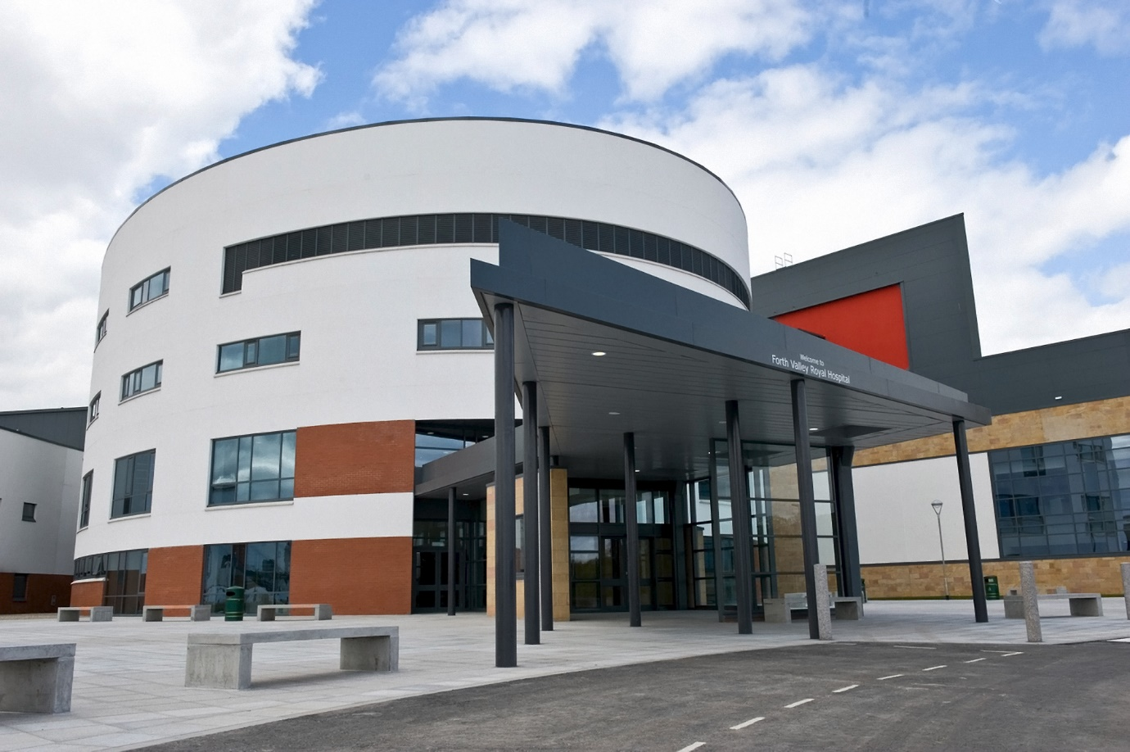
Contacts
Name of Contact | Designation in hospital | Email address
Dr Kate Patrick | Director of Medical Education | kate.patrick@nhs.scot
Dr Chris Kelly | Sub Dean/Deputy Director of Medical Education | Chris.kelly@nhs.scot
Rachael Angus-Felton | Undergraduate Coordinator | margot.robinson@nhs.scot

Clinical Teaching Fellows
Name of Contact | Email address
Dr Rebecca Gibney | Rebecca.gibney2@nhs.scot
Dr Arman Shirandami | arman.shirandami@nhs.scot
Dr Craig Anderson | Craig.anderson4@nhs.scot

Forth Valley Medical Education Website
This website gives information to students about their attachment and has an event page detailing all the tutorials and teaching events. And can be accessed on https://fvme.org/

Organised Educational Events
Medicine
Organised Educational Events | Session details
Dr Scougal Bedside teaching | Monday afternoons for Glasgow and Edinburgh medicine students
Monday Medical meeting | Monday 12.30pm, lecture theatre
Undergraduate Grand Round | Every Friday 2pm
Tutorials | CTF led session once weekly
Clinical Skills/Simulation (RMSP) | 1 per attachment

Surgery
Organised Educational Events | Average number per week
Tutorials | An average of 5 consultant led sessions per week in person/via Teams  Opportunity to join the MDTs weekly

Other teaching opportunities
Organised Educational Events | Average number per week
Radiology teaching | 10.30am every Wednesday in seminar room. 4 topics: CXR, AXR, Ct head and common fractures.
FY1 teaching | Thursday at 12pm, lecture theatre

Wards
Wards | Type of ward
A11 | Medical Boarders
A12 | Gen Med incl Endocrine & Haematology
A21 | DOME
A22 | DOME
A31 | Infectious diseases
A32 | DOME
B21 | Stroke
B31 | Respiratory/Gen Med
B32 | GI/ Gen Med
AAU | Medical Acute Receiving

On the wards students are expected to participate in ward rounds and assist the FY1s and Registrars in general ward work. There will be opportunities for bedside teaching on the ward and in Acute Receiving, there is the opportunity to clerk in patients.

Travel
- From the accommodation, the hospital is a 20 minute bus ride; free bus vouchers are issued to students to travel between the accommodation and the hospital
- Students can park in the Purple Car Park at the rear of the hospital
- There are bike racks at the hospital which students are able to use
- If students wish to commute daily they will be compensated to the equivalent of the bus fare

Hospital Location
Click Map below to go directly to Google maps
Forth Valley Royal Hospital - Google Maps
Hospital address:
Forth Valley Royal Hospital
Stirling Road
Larbert
FK5 4WR

Accommodation
- Students are offered accommodation whilst on placement at Forth Valley
- The students are accommodated in what was previously the Junior Doctor's Residence on site at the Falkirk Community Hospital
- There are two floors with 16 en suite bedrooms with a kitchen, sitting room and laundry room on each floor
Amenities | Yes/No | Other remarks
Iron | Yes | Iron & Ironing board provided
Stove for cooking | Yes | 2 per floor
Utensils | Yes
Microwave | Yes | 2 per floor
Oven | Yes | 2 per floor
Heater | Yes | Centrally heated
Warm water for bathing | Yes
Pillows | Yes
Duvet/ blanket | Yes
Study table | Yes
Study lamp | Yes
The accommodation is not accessible to Forth Valley by foot which is why bus passes are provided. Some students cycle.

Food
- A meal in the hospital canteen costs £5 on average
- The food served ranges from theatre cooking of steak and onion baguettes and fajitas, as well as more traditional dishes e.g. fish and chips, macaroni cheese, toasted sandwiches, wraps and a variety of salads and fruits
- Food can also be bought from a Marks and Spencer, WHSmith, Starbucks and Costa which are all in the hospital; there is also a RVS café

Library and Computer Resources
- There is a library which students have access to 24/7
- Students are permitted to borrow books from the library
- Students are given their own loaned copy of the Oxford Handbook relevant to their attachment at the beginning of each block
- Students are also given SHELCAT accounts which allows them to borrow books from other Scottish hospital libraries
- Students are also offered the opportunity to register for an Athens password and usernames which gives them access to: Knowledge Network, on-line educational resources, numerous point-of-care resources e.g. BNF, BMJ Best Practice, mobile apps and range of e-books
- The library also offers tutorials on all the above; the aim is to ensure that the doctors of the future are fully familiarised with the scope of information available to them
- Students are given access to hospital computers
- There are 17 computers in the library and a further 11 computers in the Open Learning Room within the library
- There is a printing service for students to use; all students are given a printer PIN code on arrival
- Printing and photocopying is free for students
Miscellaneous
- There are shower and changing facilities within the hospital which students are able to use.
- The Doctors Mess, which is very small, is not accessible to students

